**PROBLEM – 5** List the location number and name of locations that are part of the “Basketball arena”. Your WHERE clause should not have a condition involving the facility number compared to a constant (“F101”). Instead, you should use a condition on the FacName column for the value of “Basketball arena”.

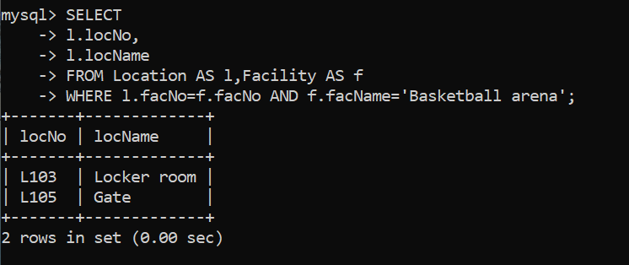

**SELECT**

**-> l.locNo,**

**-> l.locName**

**-> FROM Location AS l,Facility AS f**

**-> WHERE l.facNo=f.facNo AND f.facName='Basketball arena';**